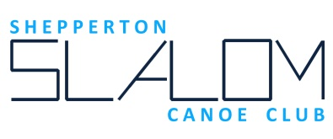

Code of Conduct: - Club Officials & Coaches

A Club Official is a member of the Committee or person deployed by the Committee.
Shepperton Slalom Canoe Club is an amateur club. All coaching and official duties are undertaken free of charge except by prior arrangement with the Committee.
The essence of good practice is summarised below.

Coaches and officials must:
Act within remits as provided by the Club as Deployer or their Coaching Qualification
and advertise activities which primarily benefit themselves as such (NB this can happen eg when coaches are being assessed or need logged sessions).
All officials & coaches are encouraged to:
consider the well-being and safety of participants before the development of performance;
develop an appropriate working relationship with paddlers, based on mutual trust and respect;
make sure all activities are appropriate to the age, ability and experience of those taking part;
promote the positive aspects of the sport (e.g. fair play, independence, risk assessment);
display appropriate standards of behaviour and appearance;

Use proper language when taking part in club activities;
Be familiar with the Club’s Codes of Conduct and Canoe England’s discipline specific rules;
Follow and promote all guidelines laid down by the national governing body and the club and hold the appropriate, valid qualifications and are further encouraged to regularly update their skills and knowledge.

Adopted at the Full Committee meeting 21/02/2017

