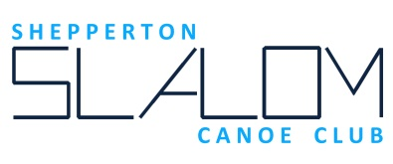

Code of Conduct: - Parents and Guardians

Encourage your child to learn and abide by the Club's Code of Conduct.
Encourage your child to learn and abide by Competition Rules and Safety Requirements.
Support your child's involvement in canoeing and help them to enjoy the sport.
Help them to recognise good performance, not just results.

Set a good example by recognising fair play and applauding the good performance of other paddlers. Discourage unfair actions.
Discourage arguing either with club coaches or competition officials. Where disputes arise, model good practice in resolving them.

Never force your child to paddle. Never punish or belittle a child for losing or making mistakes.
Use correct and proper language at all times when taking part in club activities
You are responsible for your child at all times unless you have agreed with another adult that responsibility is transferred to them. Familiarise yourself with and abide by the Club's Welfare Policy.
Adopted at Full Committee meeting 21/02/2017

